Author Name, Second Author Name[1]

Paper Title Times New Roman 16 bold black[2]

# Paragraph title Times New Roman 12 bold black

Text Times New Roman 12 black. Lorem ipsum dolor sit amet, consectetur adipiscing elit, sed do eiusmod tempor incididunt ut labore et dolore magna aliqua. Ut enim ad minim veniam, quis nostrud exercitation ullamco laboris nisi ut aliquip ex ea commodo consequat. Duis aute irure dolor in reprehenderit in voluptate velit esse cillum dolore eu fugiat nulla pariatur. Excepteur sint occaecat cupidatat non proident, sunt in culpa qui officia deserunt mollit anim id est laborum.

From the second paragraph onwards there is no indentation. Lorem ipsum dolor sit amet, consectetur adipiscing elit, sed do eiusmod tempor incididunt ut labore et dolore magna aliqua. Ut enim ad minim veniam, quis nostrud exercitation ullamco laboris nisi ut aliquip ex ea commodo consequat. Duis aute irure dolor in reprehenderit in voluptate velit esse cillum dolore eu fugiat nulla pariatur. Excepteur sint occaecat cupidatat non proident, sunt in culpa qui officia deserunt mollit anim id est laborum.

# *2.1 Sub-Paragraph title*

Lorem ipsum dolor sit amet, consectetur adipiscing elit, sed do eiusmod tempor incididunt ut labore et dolore magna aliqua. Ut enim ad minim veniam, quis nostrud exercitation ullamco laboris nisi ut aliquip ex ea commodo consequat. Duis aute irure dolor in reprehenderit in voluptate velit esse cillum dolore eu fugiat nulla pariatur. Excepteur sint occaecat cupidatat non proident, sunt in culpa qui officia deserunt mollit anim id est laborum.

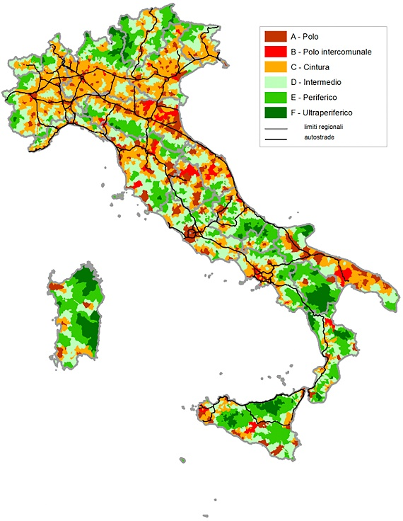

Fig. 1 - Classification of the Italian Territory according to the National Strategy of Inner Areas, 2014.

Elaborated on Department for Cohesion Policies data.

Long citation:

«Lorem ipsum dolor sit amet, consectetur adipiscing elit, sed do eiusmod tempor incididunt ut labore et dolore magna aliqua. Ut enim ad minim veniam, quis nostrud exercitation ullamco laboris nisi ut aliquip ex ea commodo consequat. Duis aute irure dolor in reprehenderit in voluptate velit esse cillum dolore eu fugiat nulla pariatur. Excepteur sint occaecat cupidatat non proident, sunt in culpa qui officia deserunt mollit anim id est laborum». (Basic demographic information or reference code anonymous of the person being interviewed)

# Conclusions

Lorem ipsum dolor sit amet, consectetur adipiscing elit, sed do eiusmod tempor incididunt ut labore et dolore magna aliqua. Ut enim ad minim veniam, quis nostrud exercitation ullamco laboris nisi ut aliquip ex ea commodo consequat. Duis aute irure dolor in reprehenderit in voluptate velit esse cillum dolore eu fugiat nulla pariatur. Excepteur sint occaecat cupidatat non proident, sunt in culpa qui officia deserunt mollit anim id est laborum.

**References**

Addie, J.-P.D., Keil, R. (2015). Real existing regionalism: the region between talk, territory and technology. *International Journal of Urban and Regional Research*, 39(2), 407–414. https://doi.org/10.1111/1468-2427.12179

Allen, J., A. Cochrane (2007). Beyond the territorial fix: regional assemblages, politics and power. *Regional Studies*, 41(9), 1161–1175.

Allen, J., Cochrane, A. (2010). Assemblages of state power: Topological shifts in the organization of government and politics. *Antipode*, 42(5), 1071–1089. doi:10.1111/j.1467-8330.2010.00794.x

Allmendinger, P., G. Haughton (2009). Soft spaces, fuzzy boundaries and metagovernance: the new spatial planning in the Thames Gateway. *Environment and Planning A*, 41(3), 617–633. https://doi.org/10.1068/a40208

Allmendinger, P., Haughton, G., Knieling, J., & Othengrafen F. (2015). *Soft spaces: re-negotiating governance, boundaries and borders.* Routledge, London.

1. Name Surname, University of XXX, mail: [mail.surname@universitymail.xx](mailto:mail.surname@universitymail.xx); ORCID: 00000000000. Name Surname, University of XXX, mail: [mail.surname@universitymail.xx](mailto:mail.surname@universitymail.xx); ORCID: 00000000000.
2. Information on the contribution: attributions, declaration on the ethical procedures for data collection, on any funding or funded projects related to the research from which the paper originated.